**Mustafa Memon**

**Ethan Herndon**

**CST 311-01**

**Programming Assignment 4**

**H1 Pings H2**

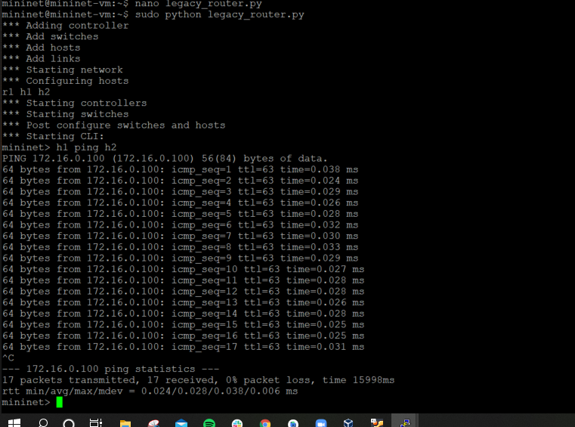

**H2 Pings H1  
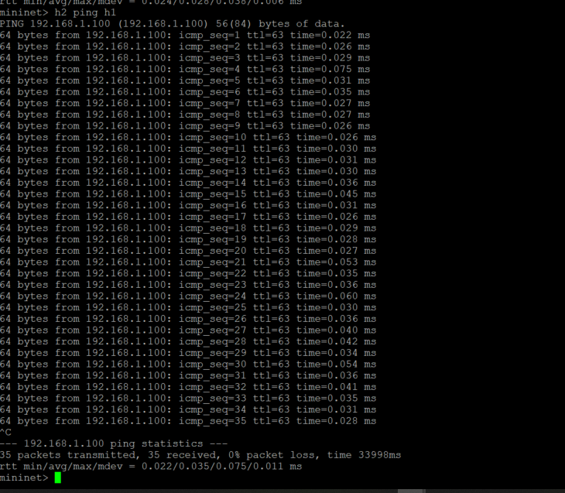**

**Diagram for Network Design**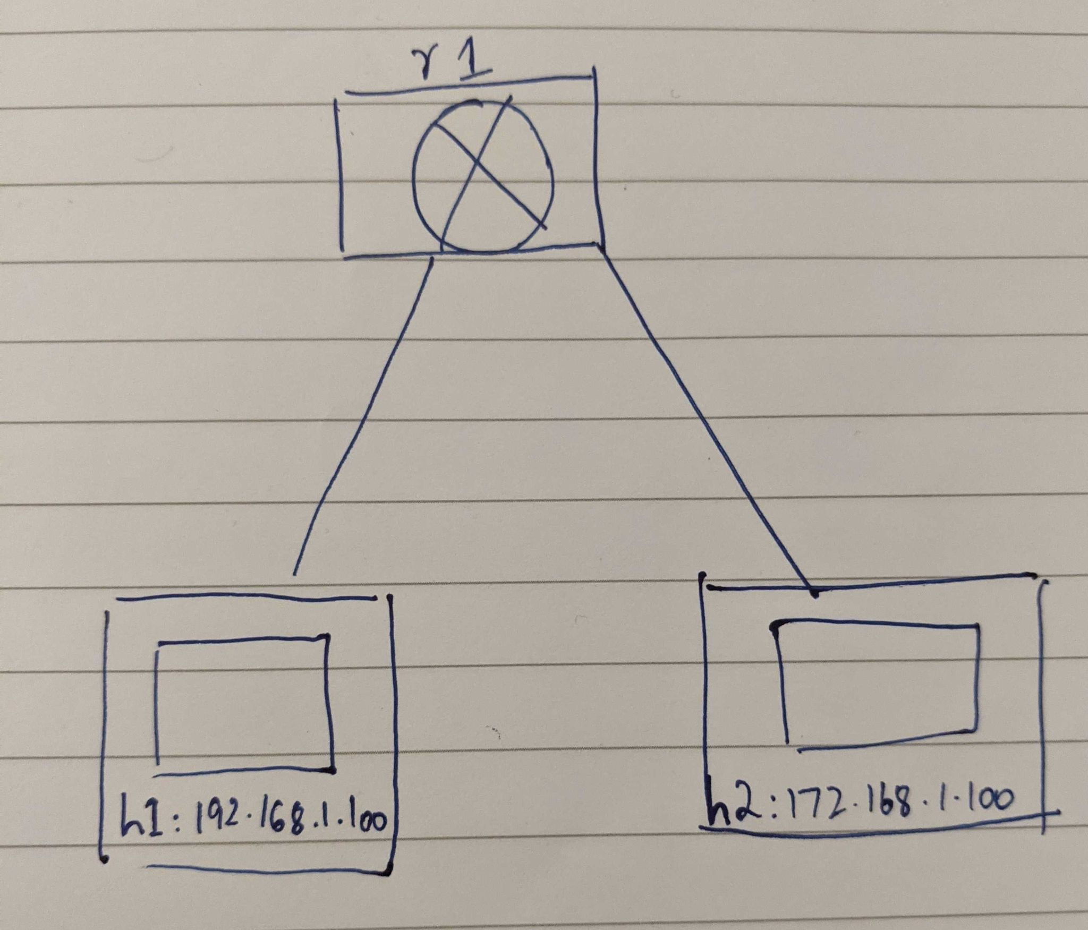

1. **(35 points)** Answers to these questions:
2. **What were any interesting findings and lessons learned?** 
   1. **It was very interesting to essentially replicate the ping functionality from Windows as a python script. The lesson that we learned was how fun and simple it is to code a program that builds a 2 host network connected by a legacy router.**
3. Why didn’t the original program forward packets between the hosts?
   1. **Because the ips for the hosts and Mininet were incorrect**
4. Is the line ‘ r1.cmd('sysctl -w net.ipv4.ip_forward=1') ’ required?
   1. **Yes**
5. Intentionally break your working program, e.g.: change a subnet length, IP address, or default route for a host. Explain why your change caused the network to break.
   1. **There is no route to the other subnet when we changed the IP address or the subnet length.**